Uterine Cervix

# Truth versus WSI (Leica)

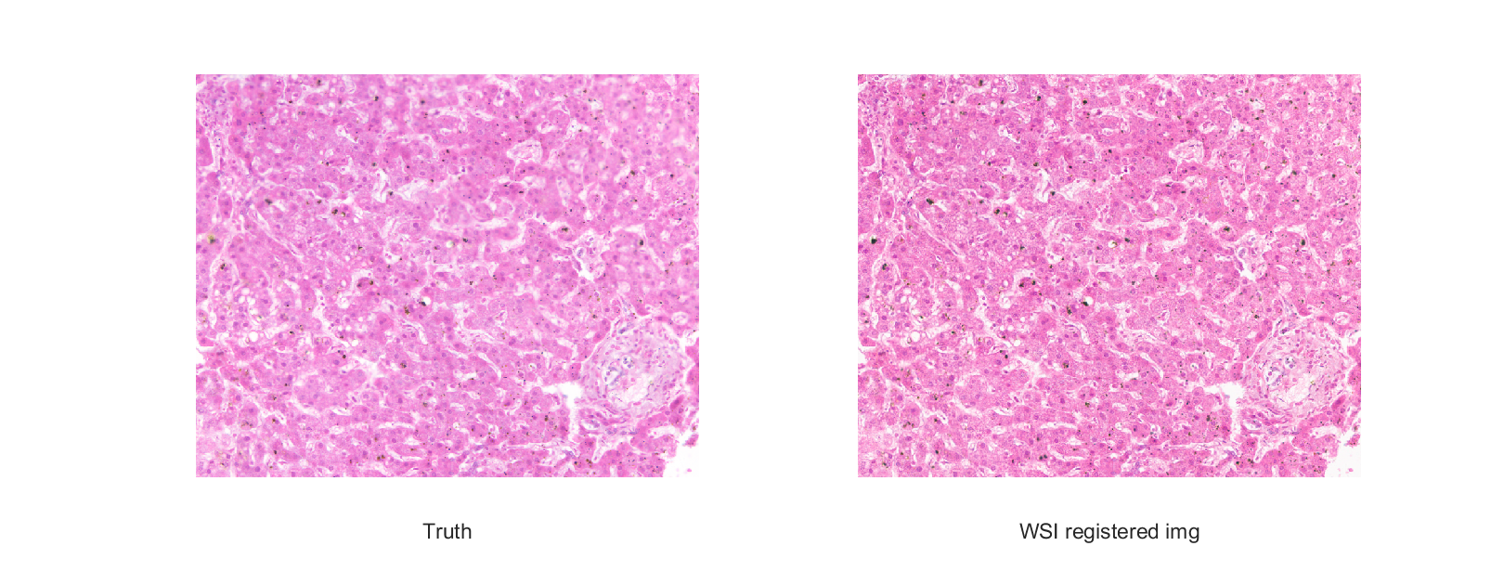

# CIELAB difference using the SRGB values from the WSI image and the CIELAB values from the measurements of the truth by the HIMS

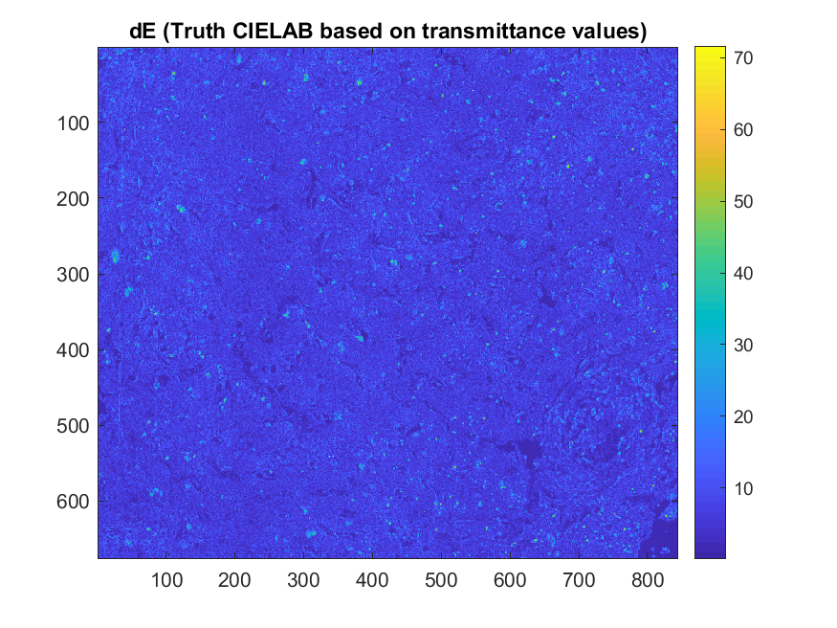

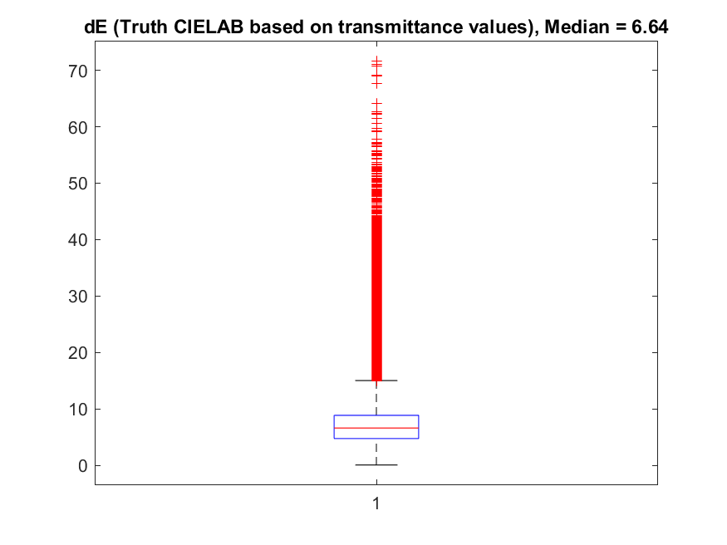

# Principal component analysis

Wavelengths 380 nm and 780 nm are removed from the dataset (no signal at these wavelengths).

Data: $T$ = (676 x 844) x 39

The data are centered, subtraction of data_mean $\overline{T}$ (along rows)

$$A=T-\overline{T}$$

SVD

$$A=U×S×V^{T}$$

Reduction of data using 5 eigenvectors

$$A_{k}=U_{k}×S_{k}×{V_{k}}^{T}$$

Reconstruction of dataset (no centered)

$$T_{k}=\overline{T}+A_{k}$$

5 eigenvectors and spectral mean of the image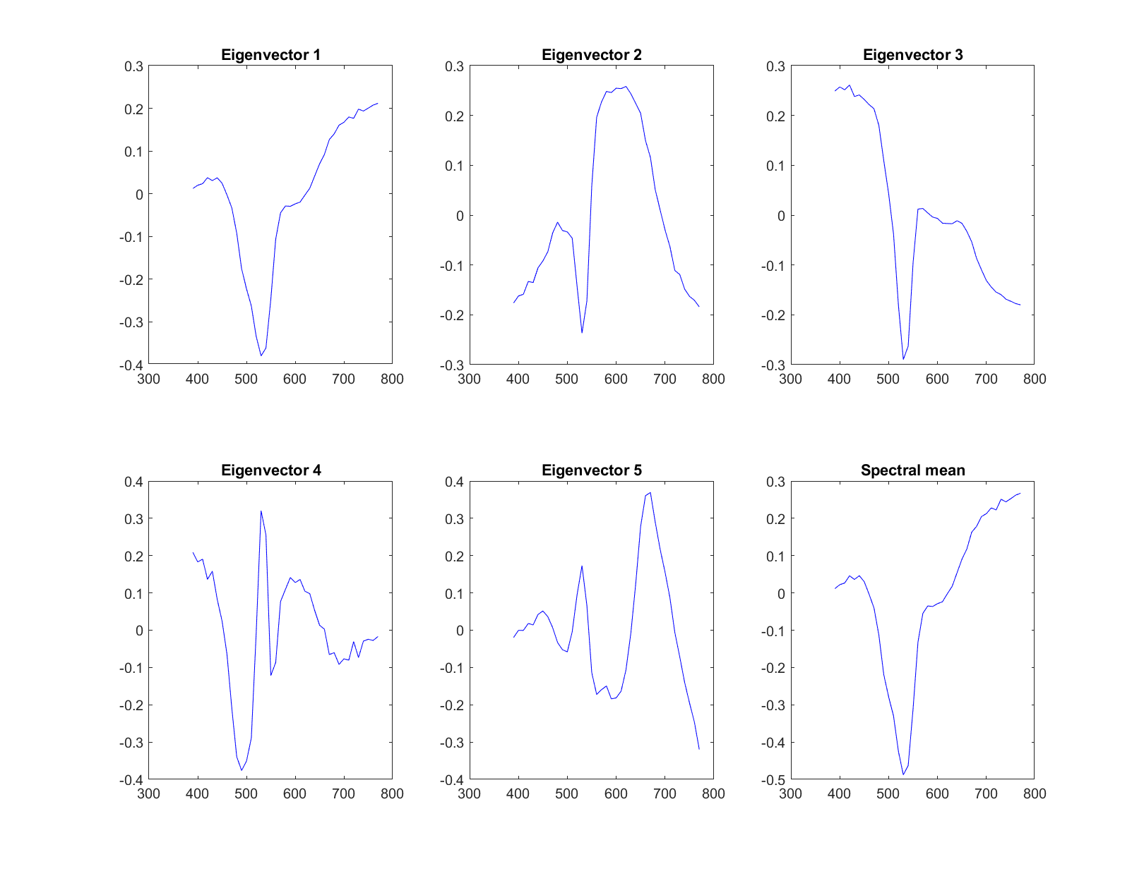

# Reconstruction of spectra for a sample of 20-or-so pixels chosen over the images using 5 eigenvectors

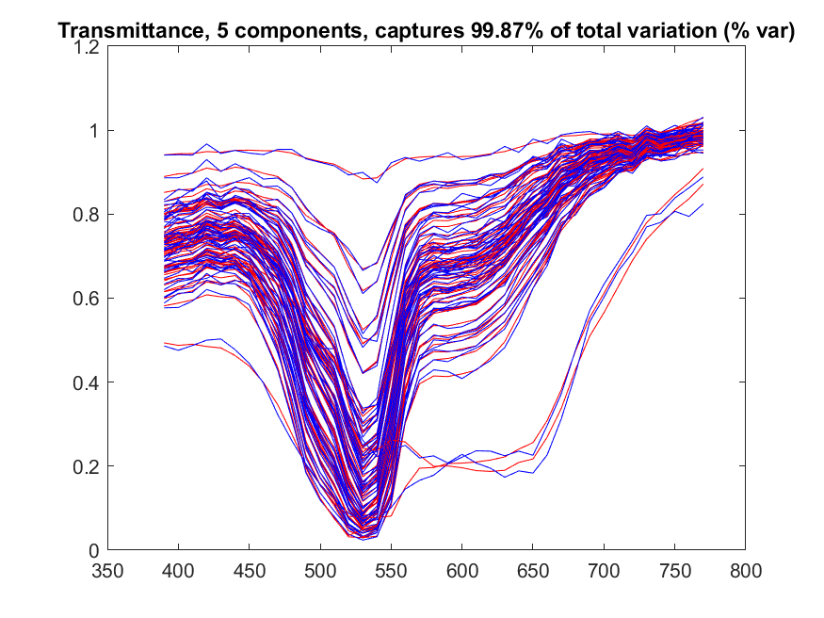

# Reconstruction of spectra of one pixels using 5 eigenvectors

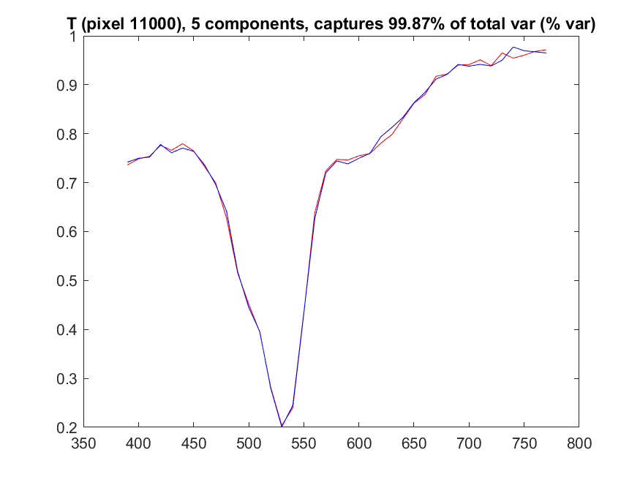

# Reconstruction of mean spectra of the image using 5 eigenvectors

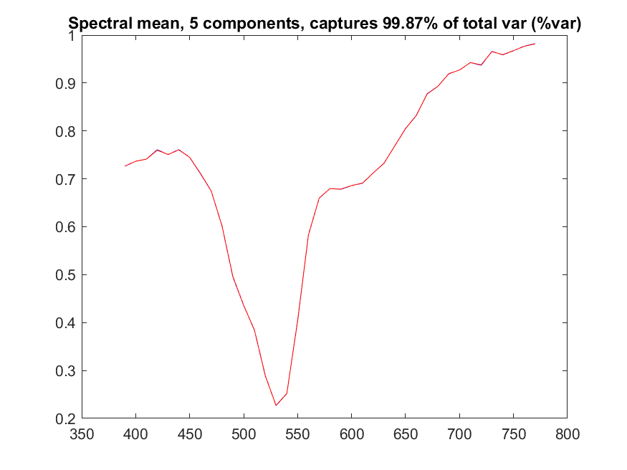

# Difference between original Truth image and the one reconstructed using 5 eigenvectors

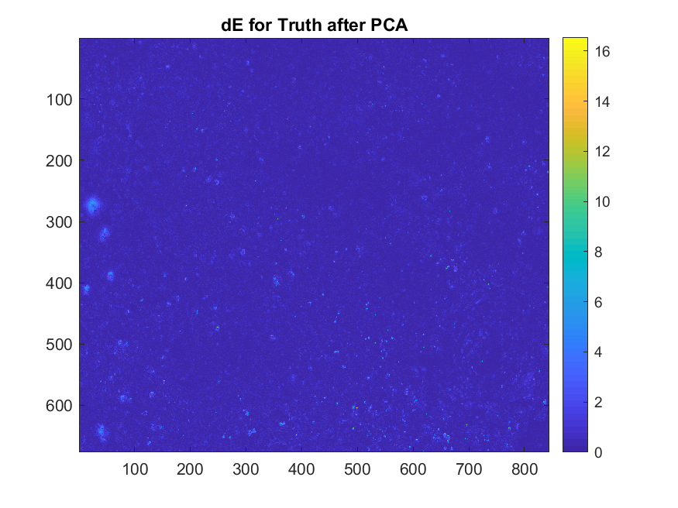

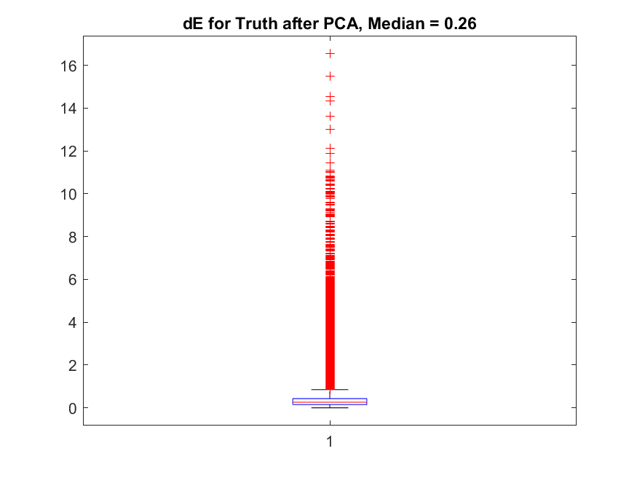

# Difference between WSI image and Truth image reconstructed using 5 eigenvectors

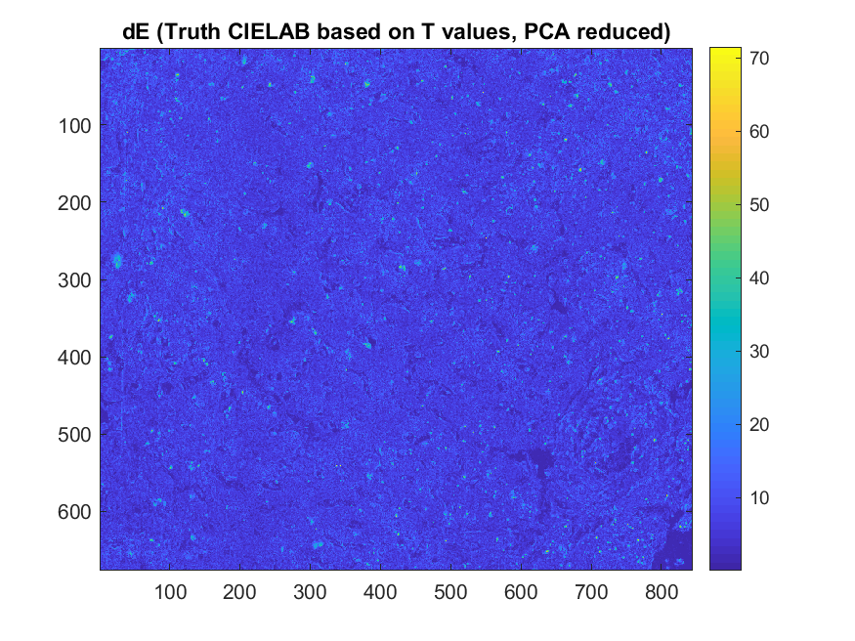

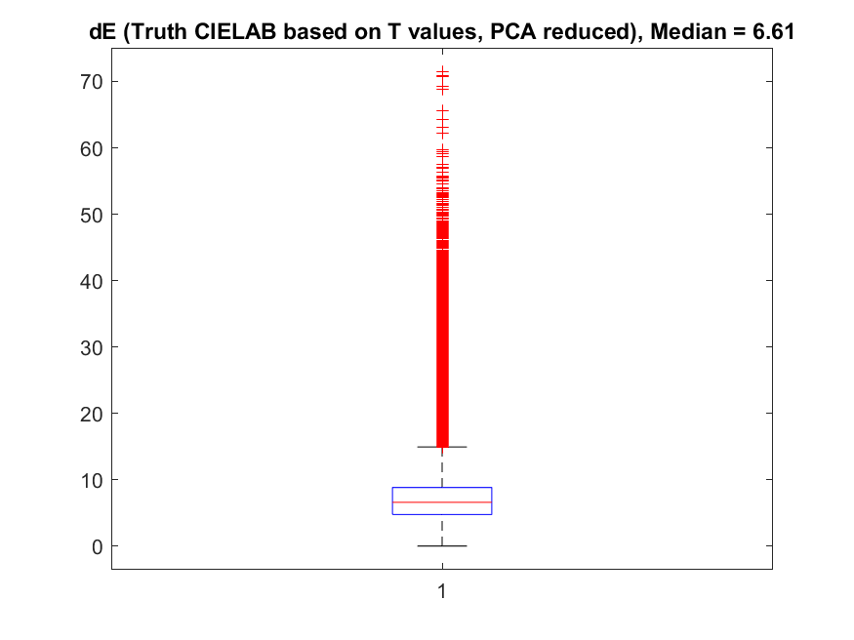

# Heatmaps of dE between WSI image and Truth images

Reduction of data using the 5 eigenvectors

$$A_{k}=U_{k}×S_{k}×{V_{k}}^{T}$$

The reconstructed data based on:

$$T_{k}=A_{k}+\overline{T}$$

with k = 1..i and i = 1..5

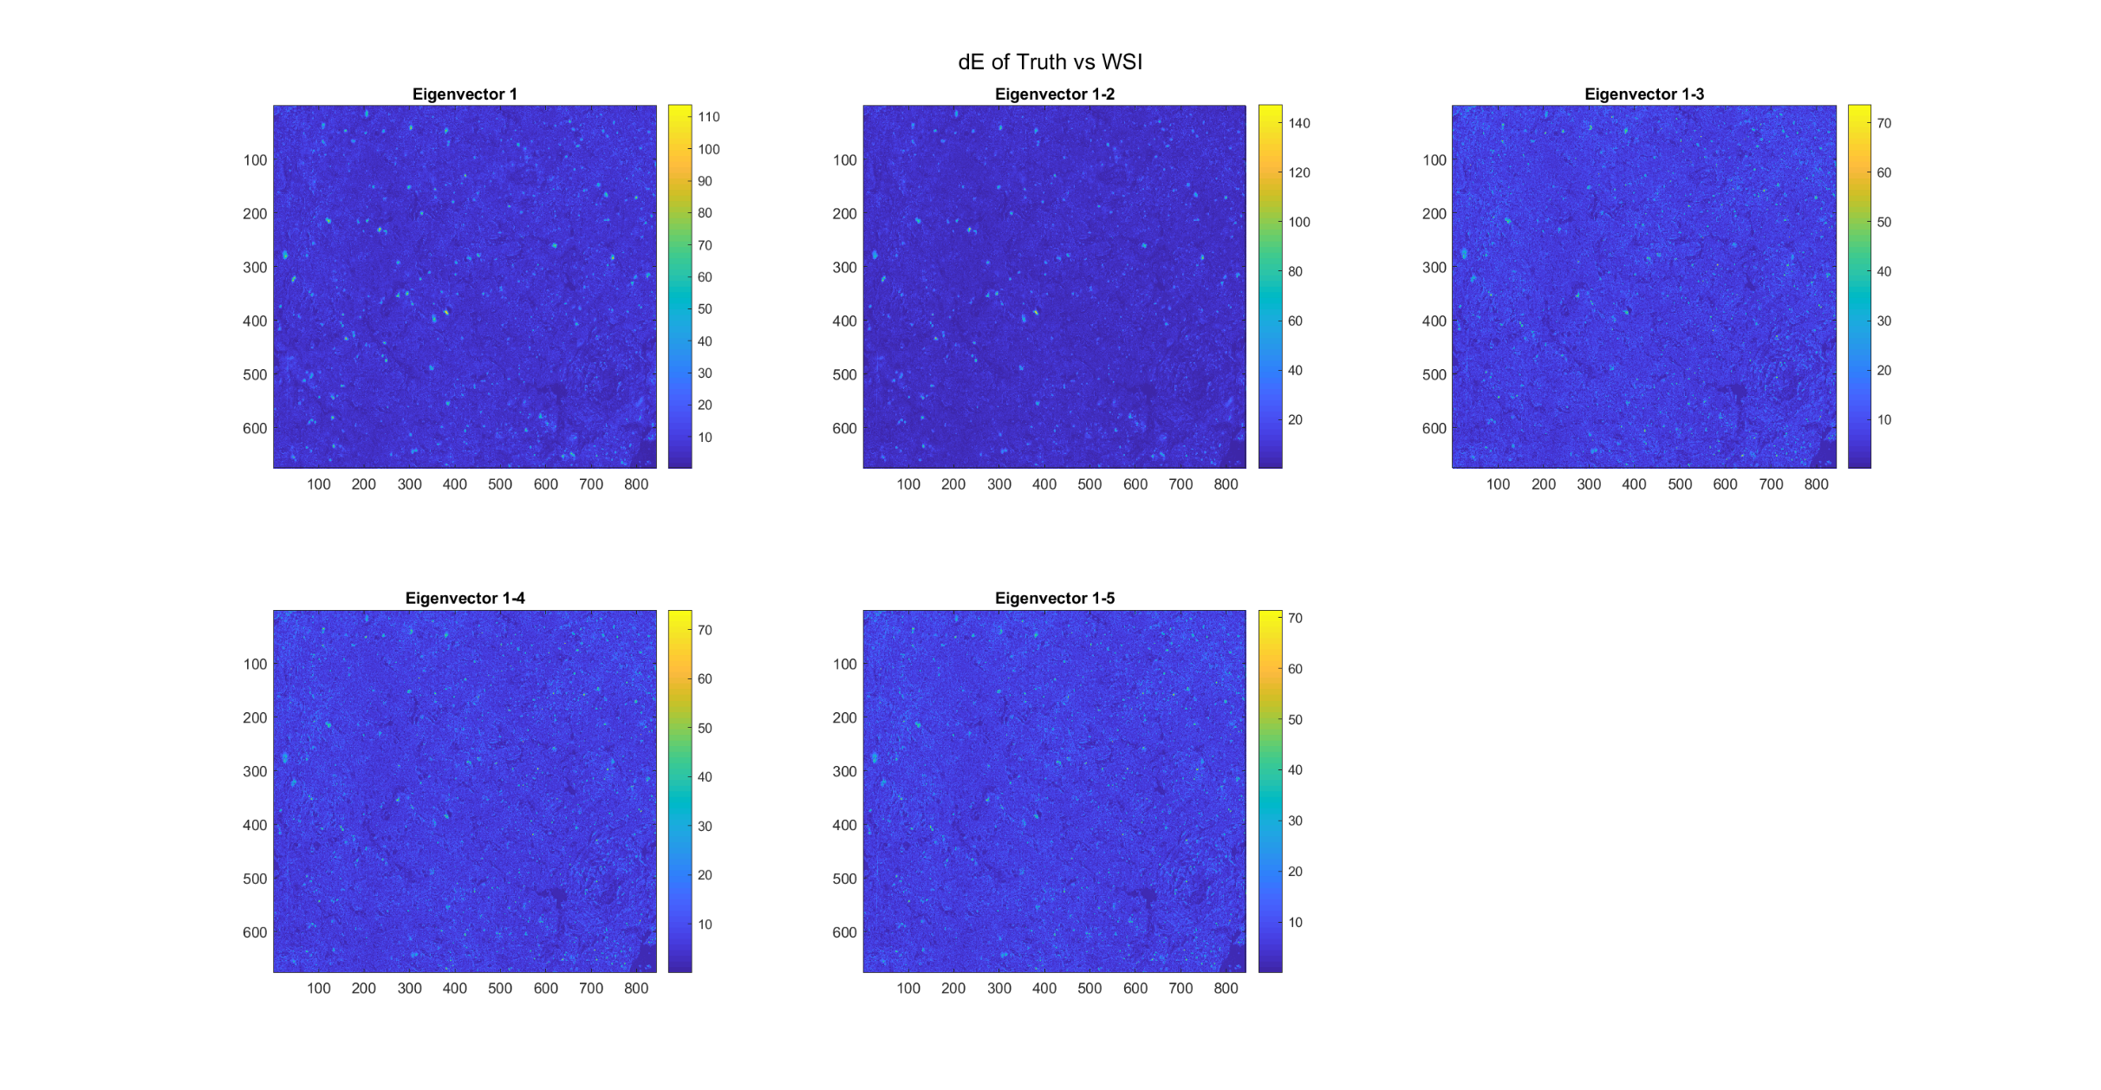

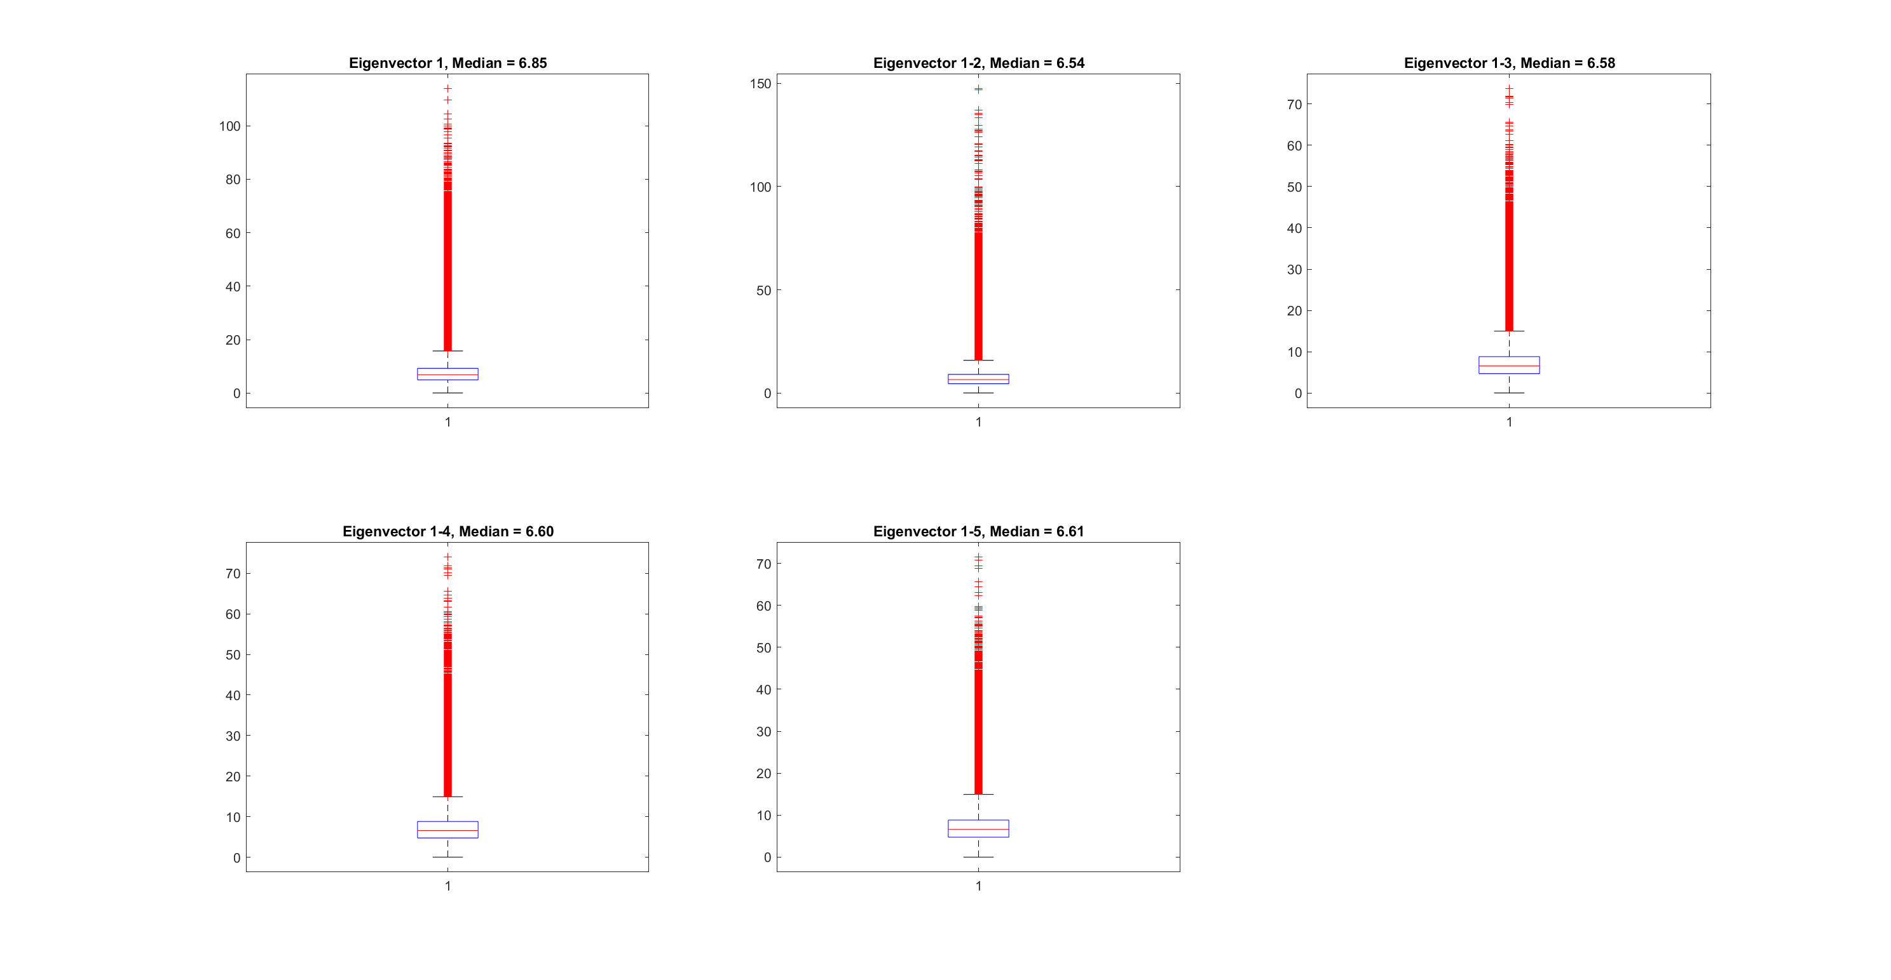

# sRGB images for $\overline{T}$ and each eigenvector component

Transformation to CIEXYZ (linear transformation) and convert to sRGB (nonlinear transformation)

$$\overline{T }\underset{→}{CIE XYZ} {XYZ}_{\overline{T }}\underset{→}{sRGB}{sRGB}_{\overline{T }}$$

$$A_{k}\underset{→}{CIE XYZ} {XYZ}_{A_{k}}\underset{→}{sRGB}{sRGB}_{A_{k}}$$

with k = 1..5, that is for each eigenvector.

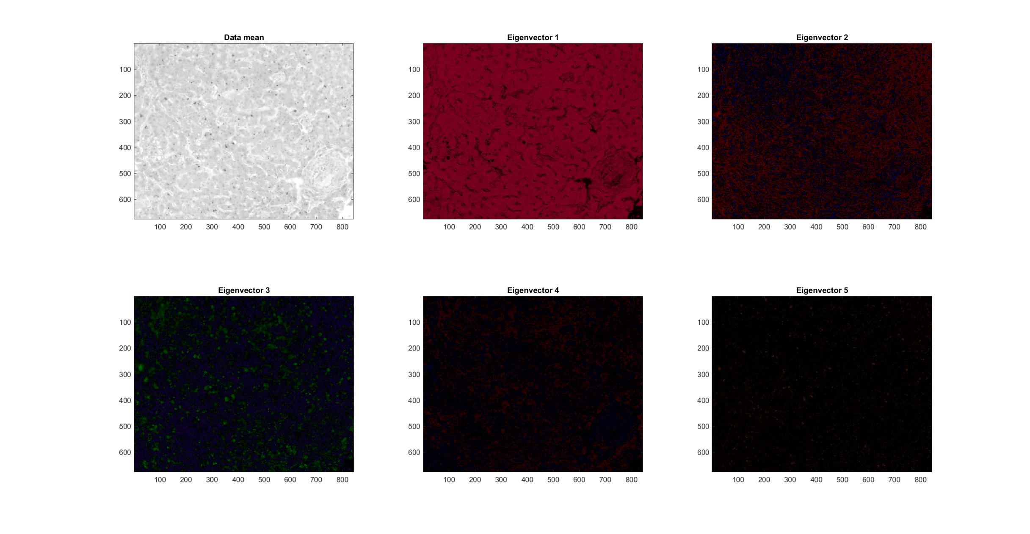

# sRGB image reconstructed using $\overline{T}$ and 5 eigenvector components

From XYZ coordinates ${XYZ}_{\overline{T }}$ and ${XYZ}_{A_{k}}$

$${XYZ}_{\overline{T }}+\sum_{k}{{XYZ}_{A_{k}}}\underset{→}{RGB linear}RGB\underset{→}{γ correction}sRGB$$

